Car rental management

PROBLEM STATEMENT:-

The existing car rental management systems lack optimal efficiency and user-friendly features, leading to operational challenges and suboptimal customer experiences. This project aims to address these issues by developing a comprehensive and intuitive car rental management solution that enhances operational processes, improves customer satisfaction, and ensures seamless communication and coordination across various facets of the car rental ecosystem. The system will incorporate advanced features such as real-time vehicle tracking, automated booking processes, and robust reporting tools to streamline operations for both the rental agency and its clientele.

Techstacks:-

1.PG admin(postgres sql)

2.PHP

3.Javascript

4.HTML

5.CSS

6.AJAX

PROJECT DESCRIPTION:

We have two interface pages separately  
  
 1.User page  
 2.Admin page

User page:-  
 User has login and signup page.Most importantly when you sign up with a email You have been sent a random OTP using SMTP.The user has to enter the correct otp to get login into our webpage.User page has home page,contact us page,about us page and a main page called carlist.Car list has the list of cars owned by us and the special features it has that was in the table.There is a book now button which redirects you to a booking page.Booking page has select dates option and we have a special price for each car for every day.After booking it automatically calculates the total price and updates in the database table.The booking is requested to the admin.

ADMIN PAGE:

Admin page can view over the number of users,number of bookings,number of brands and vehicles.The admin can also view the details of the above mentioned.The Admin page has the main important function of accepting and cancelling the trip.The admin can cancel and accept by just clicking a button which is send as a mail to the user regarding cancel and confirm button.The admin can insert and update the vehicles he have.

ER DIAGRAM:-

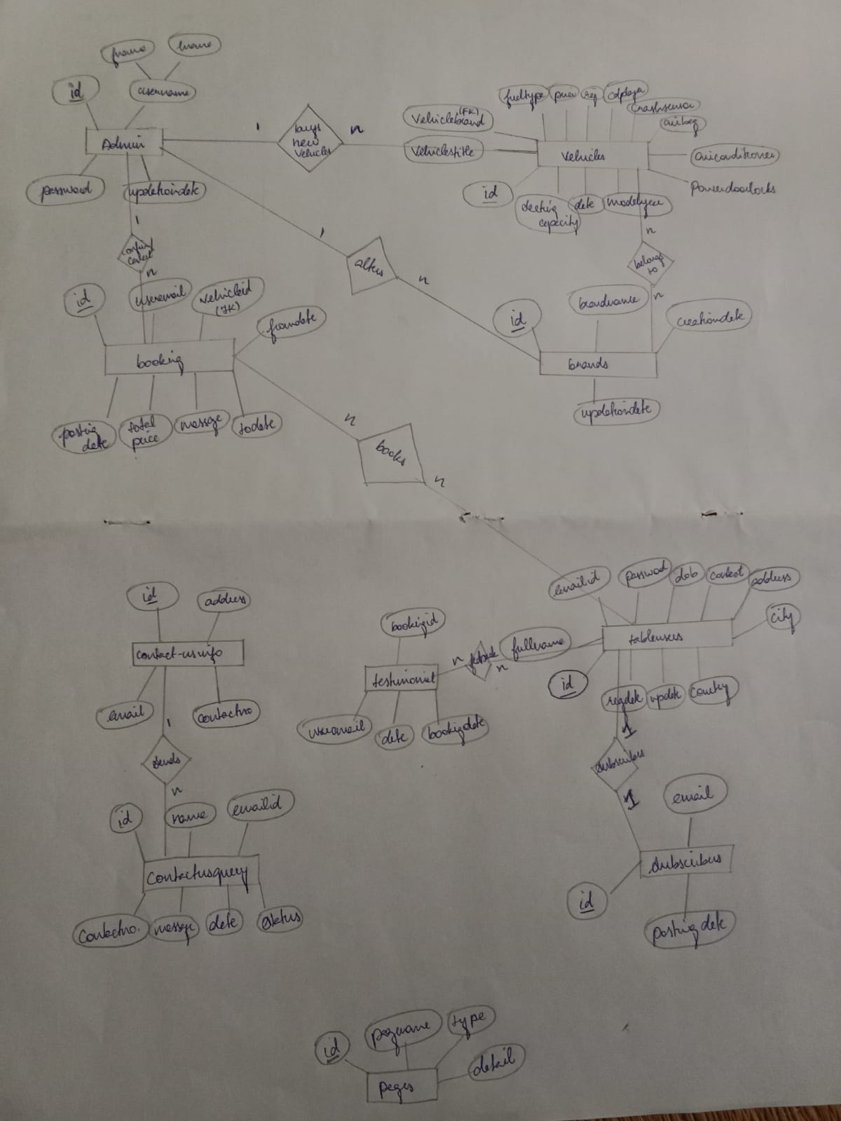

NORMALISED TABLES:-

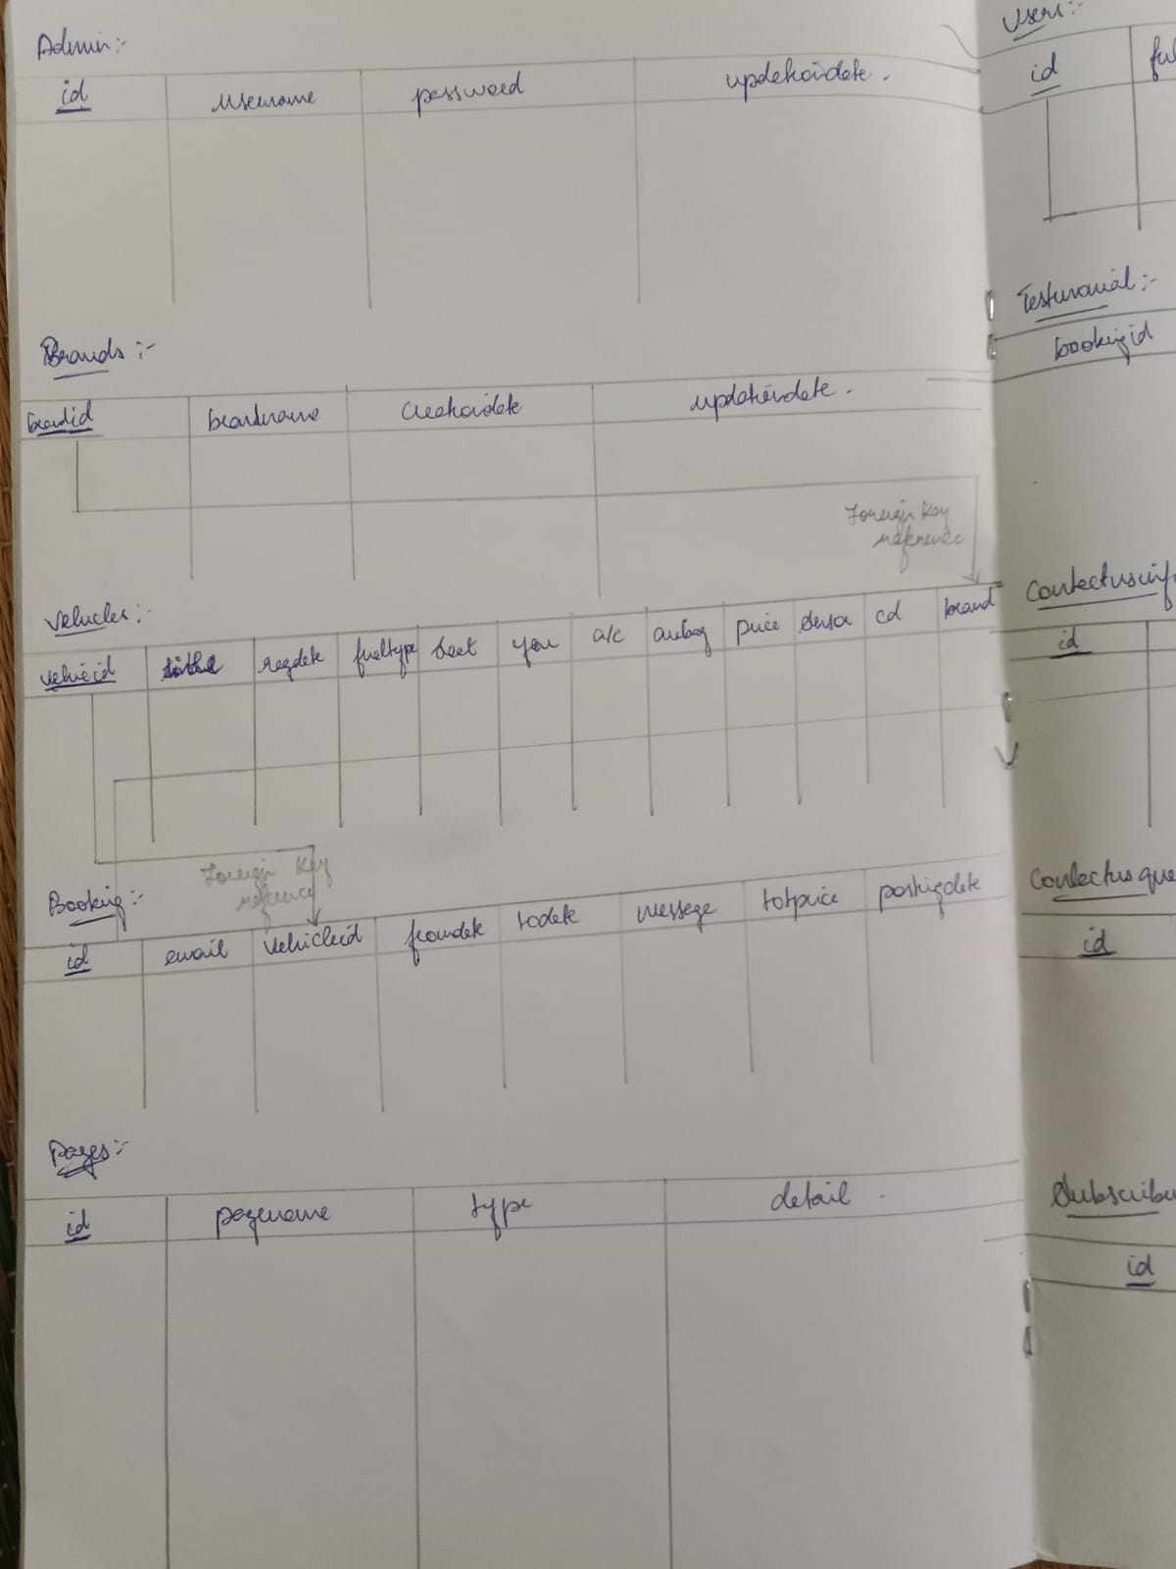

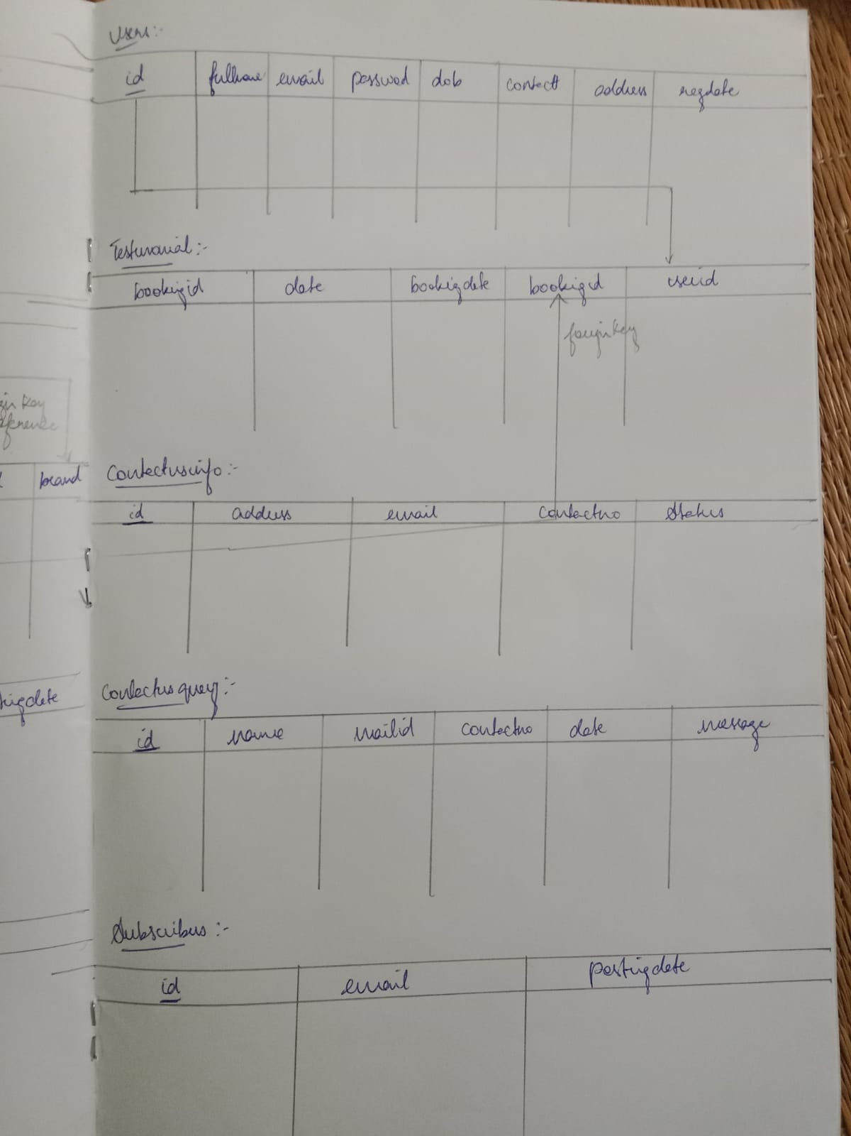

User pages:-

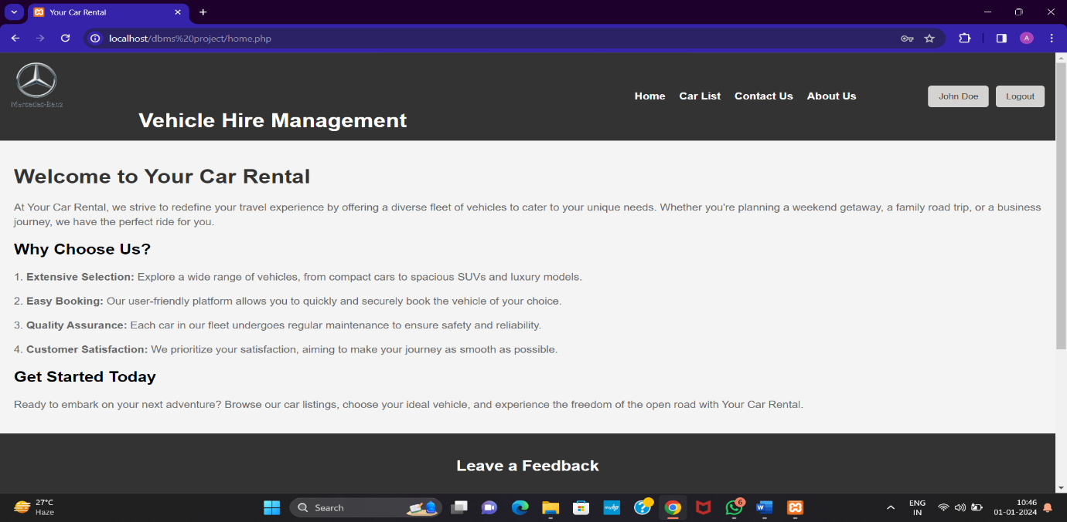



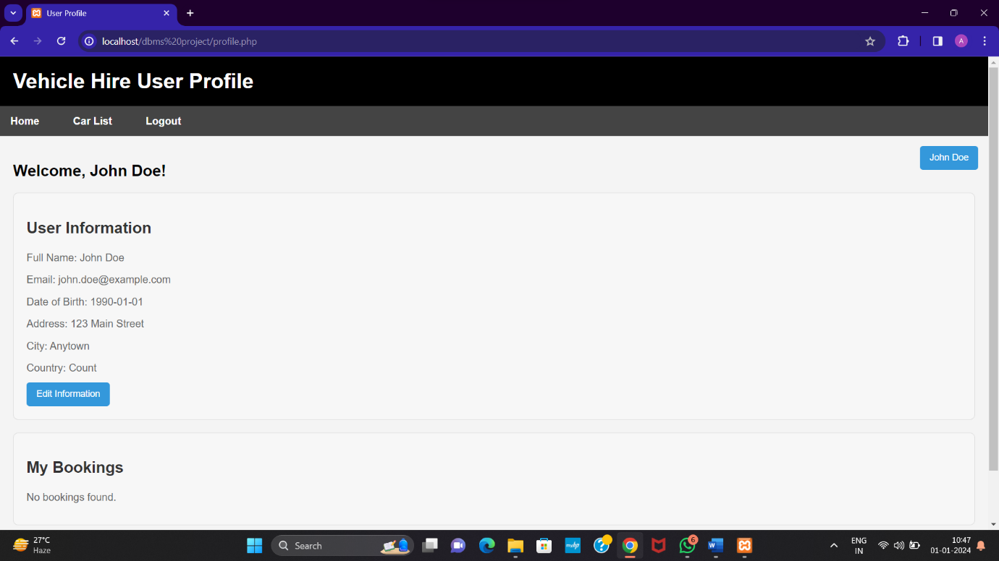

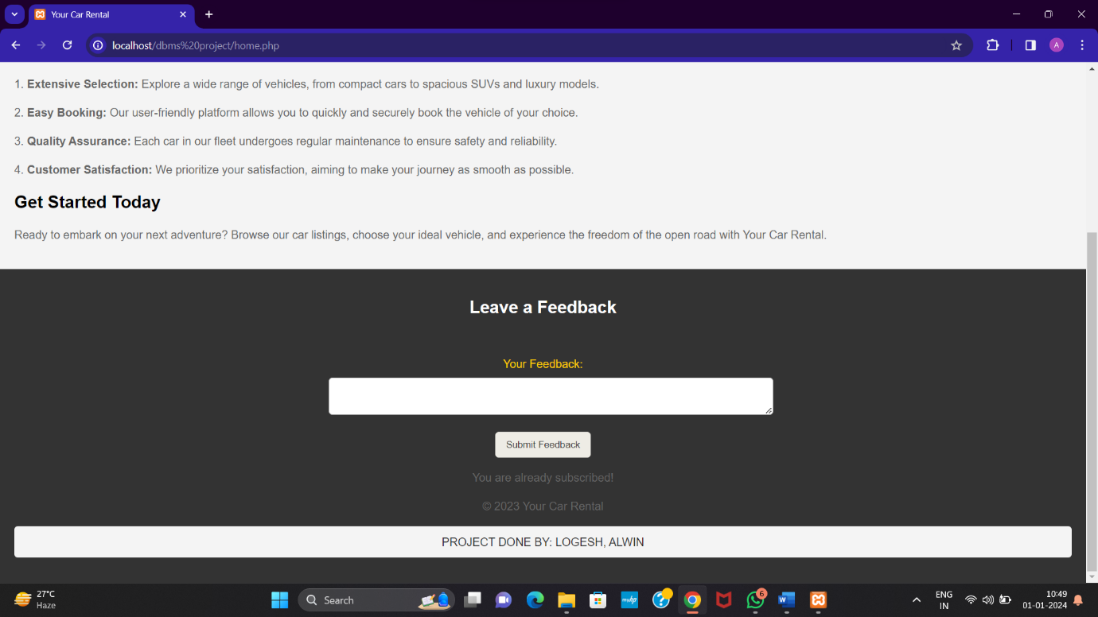

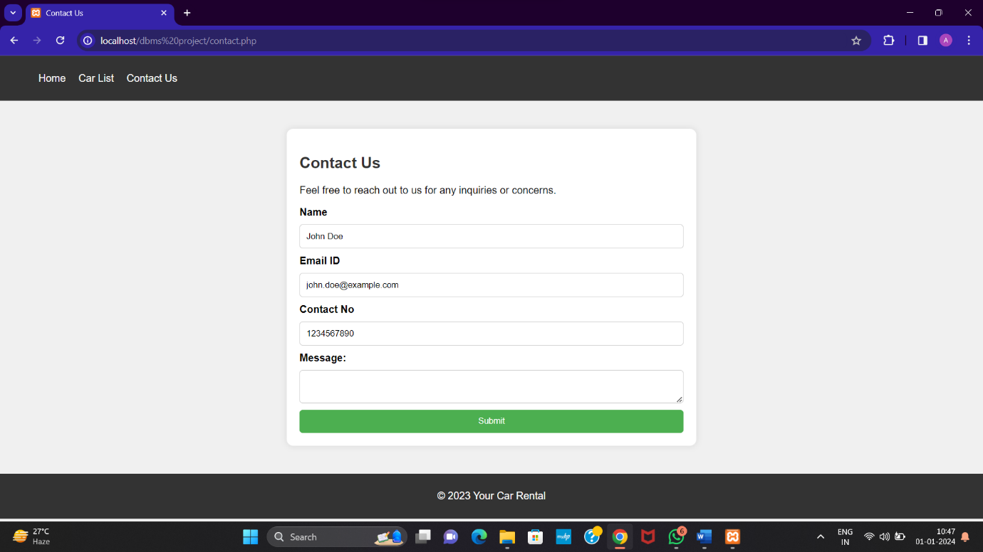

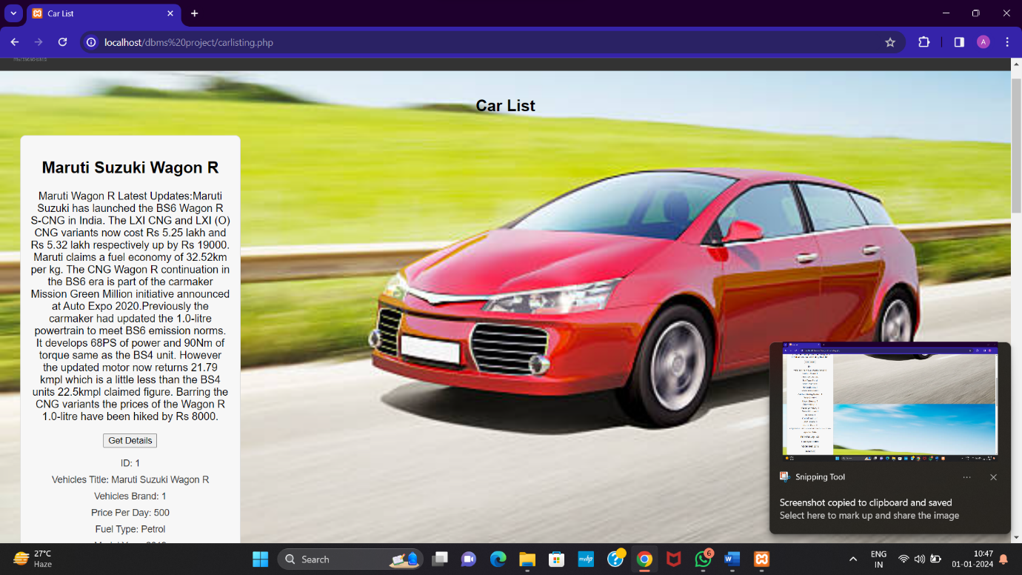

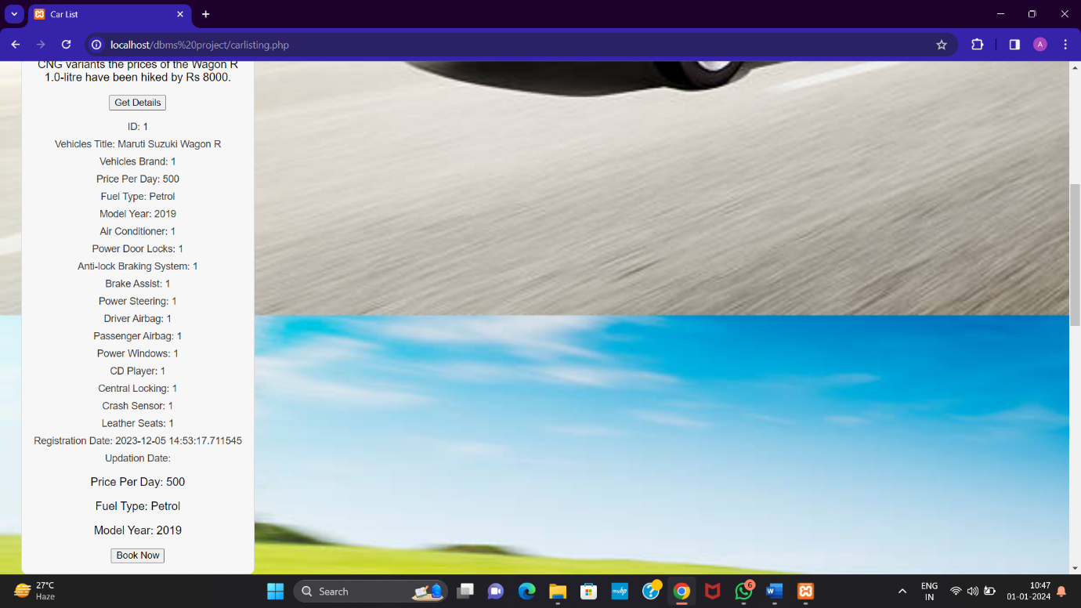



Admin pages:-

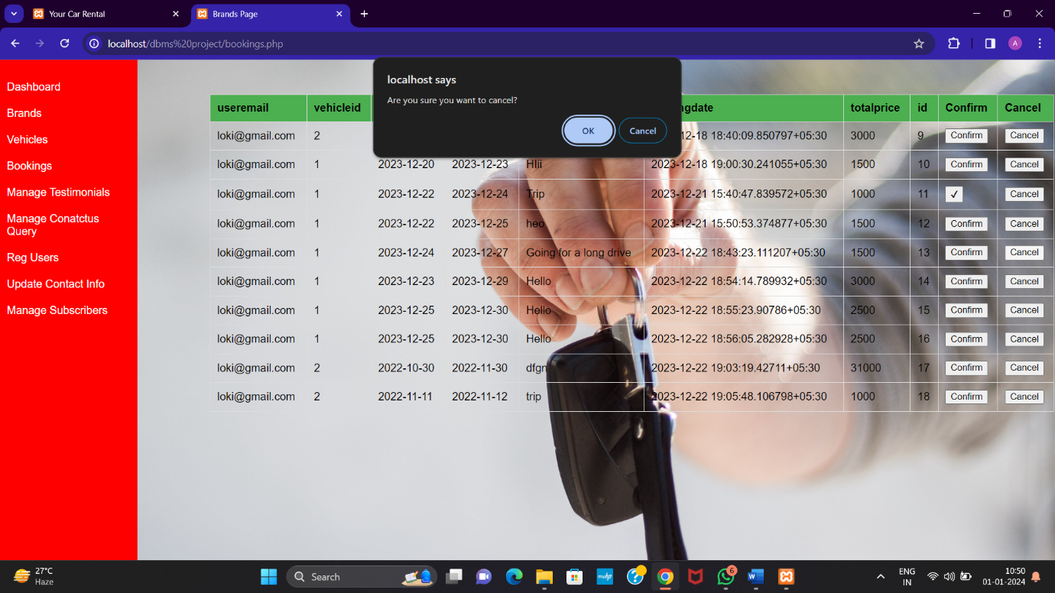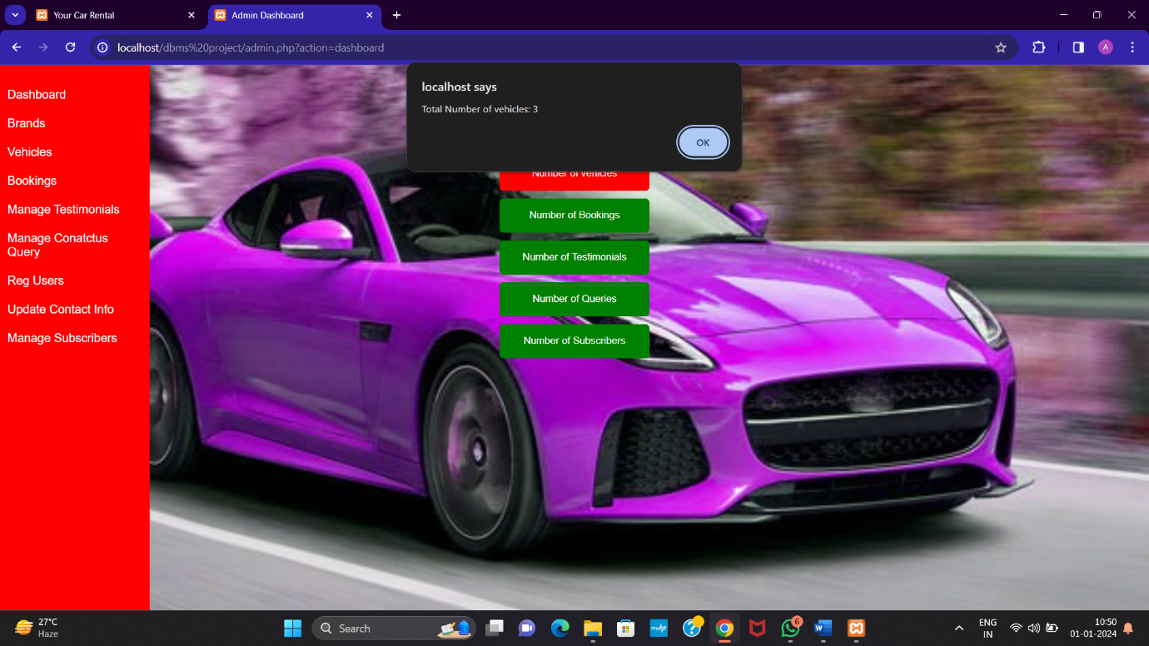

Booking pages:-

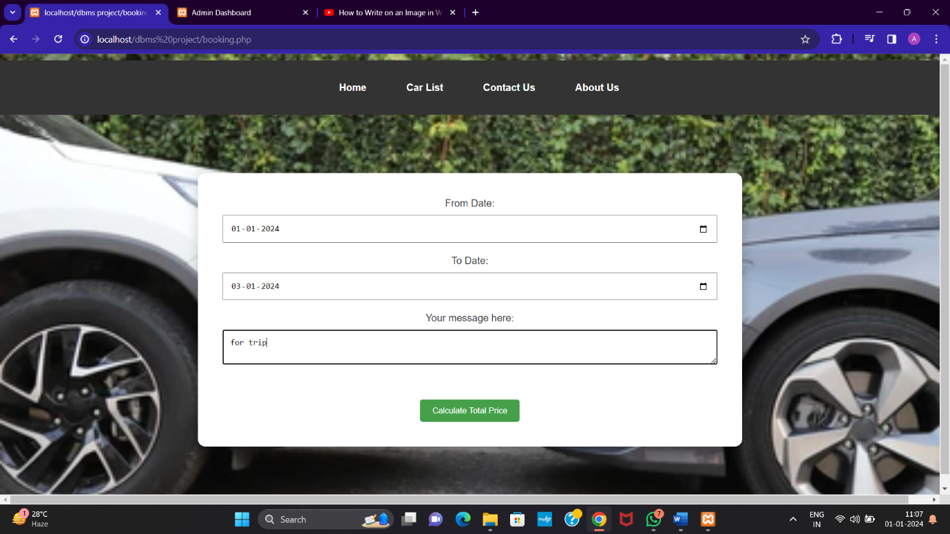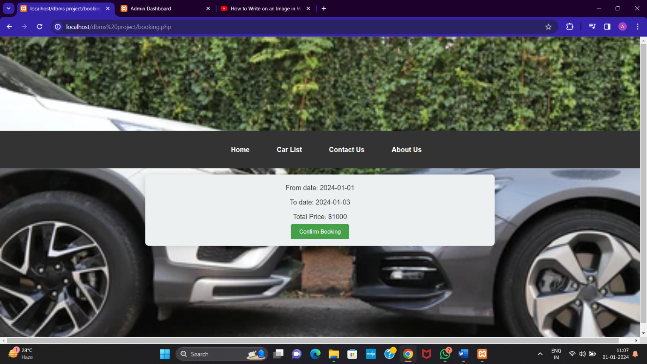

CALCULATE PRICE AUTOMATICALLY

Otp MAIL:-

